**GENERAL HUMAN BIOLOGY – YEAR 11**

**TASK 7 – DNA EXTRACTION PRACTICAL**

**NAME: ____________________________________ WEIGHTING: 10%**

**DATE: ____________________________________ MARK: _____ / 48 = _____ %**

**This assessment has been broken into multiple sections. To gain full marks, all sections must be completed and in the correct order.**

**Part A – Research and development (6 marks)**

**You are to design a practical for creating a model of DNA. A list of materials will be given to you.**

The research and write-up of the practical will be completed for homework.

**Please note: if you do not complete this homework you will not be able to complete Part B of the assessment**

**Part B – Model Practical (22 marks)**

**Using the practical you developed in Part A, you will create a model of a section of DNA and answer questions on DNA.**

**Part C – DNA Comprehension (20 marks)**

**Complete a series of questions in relation to DNA, models and the use of DNA**

**Part A – Research and development (6 marks)**

**Background Information:**

The chemical structure of DNA was first described in 1953 by James Watson and Francis Crick working at Cambridge, England, using the work of Rosalind Franklin and Maurice Wilkins. DNA has since been described as a twisted ladder or more scientifically as a double helix. It has two side chains rails with cross links or rungs between. It was important to understand the structure of DNA in order to explain how cells reproduce and how cells make proteins. It is now the basis for understanding genetic variations and disorders.

**Research:**

You must research and create a method to build a model of DNA. You will use your method to create a model of DNA in your next class.

You may use any resource available to you to develop your method, including the internet.

Below is a list of materials you may use to create your model of DNA.

* Styrofoam balls
* Pipe cleaners
* Matchsticks
* Popsicle sticks
* Coloured paper
* Hessian twine
* String
* Plasticine
  + If you require other equipment (within reason) you can ask on the day you complete the assessment.

**Part B – Model Practical (22 marks)**

1. Using the method you developed, create a model of DNA.
   * When you have finished you are to hand it in to your teacher. (6 marks)
2. Complete the following questions:
3. How many bases are found in DNA? (1 mark)
4. Which bases form pairs? (2 marks)

1. What is a helix? (1 mark)
2. DNA is described as a ‘twisted ladder’. Is this a good analogy? Explain your response. (3 marks)
3. Where is DNA found in a cell? (3 marks)
4. When is DNA visible in a cell? (3 marks)
5. How can such a large molecule fit into the small nucleus of a cell? (3 marks)

**Part C – DNA Comprehension (20 marks)**

DNA extraction can be used during DNA Profiling. DNA profiling can be used for a range of reasons, including forensic investigation, paternity testing, inheritance of disease and identification.

**Background Information:**

A child inherits half its chromosomes, and hence its DNA, from each of its biological parents. In cases of disputed paternity, DNA profiles are obtained from the child and then those who claim to be the biological parents of the child. Each band on the child’s DNA profile must match either the mother or father’s DNA profile (as seen in the diagram below). Thus, ensuring that the parents are in fact the biological parents.

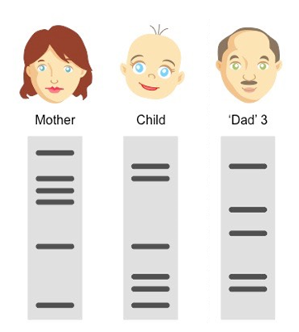

Attached to this assignment are two (2) articles on the use of DNA profiling. Read these articles and respond to the questions below.

**Questions**

1. Using your own words, write a brief summary on what each article was about.  
   1. ARTICLE 3 (3 marks)

* 1. ARTICLE 4 (3 marks)

1. Who and why would people want DNA testing/profiling to be completed?

(3 marks)

1. 1. When creating a new individual (child), what form of cell division do gametes (sex cells) undergo? (1 mark)
   2. Why is this important for the survival of the child? (3 marks)
   3. DNA holds the genetic code to create an individual. Every person has the same sets of genes (traits) in their chromosomes. How is it that most people (except identical twins) have a different genetic code? (4 marks)

1. In article 3 and 4 parents were tested for paternity of children. In both instances, the people who were thought to be parents were not. How does DNA profiling allow paternity testing to occur? (3 marks)
2. In article 4, parents (Whitney Rogers and Kevin Chittum) had died before the hospital could perform DNA profiling to determine paternity. Explain how the hospital could determine if they were the biological parents of the child being raised by Paula Johnson and Carlton Conley without digging up their graves?

(3 marks)